AIRWAY RESERVATION

***Submitted by***

**NAVEEN R (412722205027)**

**VINCENTRAJ S (412722205051)**

**SURENDAR S (412722205047)**



**DEPARTMENT OF INFORMATION TECHNOLOGY**

**TAGORE ENGINEERING COLLEGE**

**Rathinamangalam , Chennai-600 127**

**THIRD SEMESTER**

**ACADEMIC YEAR: 2023-2024**

AIRWAY RESERVATION

1. **INTRODUCTION**

# The Airway Reservation System is a software application designed to facilitate airline ticket booking and management processes. It provides an easy-to-use interface for customers to search for flights, book tickets, make payments, and manage their reservations. Additionally, it offers administrative functionalities for airline staff to manage flight schedules, seat availability, and customer bookings efficiently.

# OBJECTIVE

1. Develop a user-friendly interface for customers to search and book flights.
2. Implement secure payment processing for ticket reservations.
3. Create an administrative panel for airline staff to manage flights and reservations.
4. Ensure data integrity and security throughout the system.

# METHODOLOGY

## Existing System

The existing Airline Reservation System is a software platform used by airlines to manage flight bookings, seat availability, passenger information, and ticketing. It includes functionalities for both customers and airline staff to interact with the system and perform necessary tasks related to flight reservations and management.

## B . Proposed System

Enhanced Flight Search: Implement advanced search options such as flexible dates, multi-city trips, and fare comparison to provide users with more choices and flexibility.

The proposed Enhanced Airline Reservation System offers a comprehensive solution to modernize and improve the airline booking and management process. By leveraging modern technologies, real-time updates, enhanced security measures, and advanced analytics, the system aims to provide a seamless and personalized experience for customers while optimizing operations for airline staff.

## C . Modules Details

## Components required:

1. Web host
2. Bootstrap
3. Database
4. Text editor

## View

## 

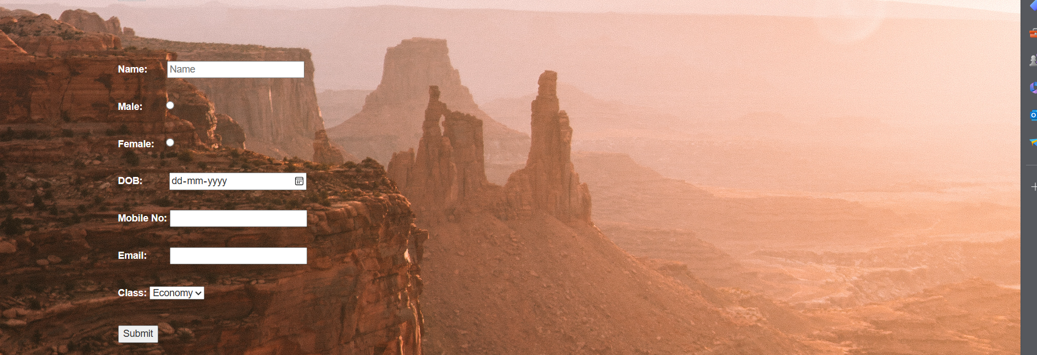

1. **WORKFLOW**

|  |  |  |  |  |
| --- | --- | --- | --- | --- |
| PROGRESS | SEP’23 | OCT’23 | NOV’23 | DEC’23 |
| 1.Gathering the requirements |  |  |  |  |
| 2.Design and Development |  |  |  |  |
| 3.Programming |  |  |  |  |
|  |  |  |  |
| 4.Testing and debugging |  |  |  |  |
|  |  |  |  |  |
| 5.Hosting the website |  |  |  |  |
| 6. Final  Assembly and Launch |  |  |  |  |

## Software Requirements

* + - Code editor for frontend development (HTML, CSS, JavaScript) like Visual Studio Code.
    - HTML, CSS, and JavaScript for building the user interface.
    - Frontend frameworks/libraries like Bootstrap, React, or Vue.js for responsive and interactive web pages.
    - HTML, CSS, and JavaScript for building the user interface.
    - Frontend frameworks/libraries like Bootstrap, React, or Vue.js for responsive and interactive web pages.
    - GitHub for hosting repositories and managing code branches.
    - Web server software like Apache or Nginx for hosting the web application.

## Hardware Requirements

* + - Processor: Intel Core i5 or AMD Ryzen 5 processor or higher
    - RAM: 8 GB or higher
    - Storage: SSD with sufficient storage capacity for development tools, IDEs, and project files
    - Operating System: Windows, macOS, or Linux (based on developer preference)
    - Processor: Intel Core i5 or AMD Ryzen 5 processor or higher
    - RAM: 8 GB or higher
    - Storage: SSD with sufficient storage capacity for development tools, IDEs, and project files
    - Operating System: Windows, macOS, or Linux (based on developer preference)

1. **FUTURE WORK :**
2. Mobile App: Develop a mobile application for iOS and Android platforms.
3. Advanced Search Filters: Implement advanced search options such as flexible dates, multiple destinations, etc.
4. User Reviews and Ratings: Allow users to review flights and provide ratings for better decision-making.
5. AI-powered Recommendations: Use AI algorithms to suggest personalized flight options based on user preferences and history.
6. **CONCLUSION**

The Airway Reservation System project has successfully automated the airline reservation process, providing users with a convenient and efficient platform for booking flights. With further enhancements and optimizations, this system aims to revolutionize the air travel industry by delivering a seamless booking experience and improving overall customer satisfaction